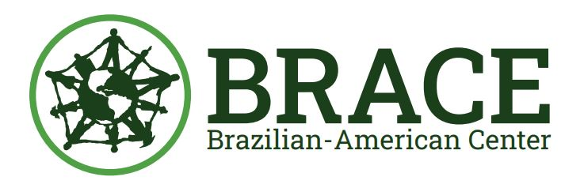
A total of 26,398 individuals received Health Insurance Assistance through BRACE between 2019 and 2023.

